
COMP 702

Web-based Diabetic Retinopathy Detection system using
Deep Learning

MUKUNDAKRISHNAN SURESH KUMAR [201604427]

Supervisor: KONSTANTINOS TSAKALIDIS

Introduction

With the advancement of science, the average life expectancy of humans has improved drastically. It came with another problem, lifestyle diseases, which are caused because of the changed lifestyle. Diabetic is said to be one of the diseases. According to WHO, in 2014, 422 million people worldwide were suffering from it. It can cause blindness, kidney failure, heart attack, stroke, and lower limb amputation. Types of diabetes, which are type 1 and Type 2, can potentially lead to severe vision loss in most people, which is called Diabetic Retinopathy (hereafter DR). in addition to these, if a person has had diabetes for more than five years, or have high cholesterol, blood pressure, and high blood sugar, and is from Asian or Afro-Caribbean background, the chances are quite high for DR [1].
DR affecting the eye can be classified into five stages:
Normal, which has no lesions. Mild non-proliferative DR, with red lesions, moderate non-proliferative DR, which has more red lesions but is less severe. Severe non-proliferative DR is more severe than the former, with a high number of red lesions. Proliferative DR has vitreous red lesions and is the most severe condition [3].
It is caused by poor food habits over time, delayed detection of the disease etc. But if a problem has been found with the eyes, proper treatment and changes in lifestyle can prevent it from getting severe and control the vision loss. There are several treatments for DR if there is a problem with the vision. If it is not, usually, it is advised to manage the diabetic levels of the patient. The treatments for patients who have vision loss include laser treatment, injection into the eyes and surgery to remove the blood and other damaged parts from the eyes.
That being said, early-stage detection is highly recommended for this disease as vision, once lost, cannot be retrieved in any matter.

Traditional Approach
Currently, it is being diagnosed clinically, and usually it takes much time in places where there is limited access to healthcare. The treatment and detection of DR is always a challenging task. At present it is done by experts by examining the fundus images. The manual process is always giving accurate results [7], because of the experienced professionals. But on the other hand, it tends to be slow as the proportion of the patients with the medical staff will be always higher. Usually, human efforts take around 7 – 14 days under professionals [2]. Since there is a scarcity of highly trained staff, patients often have to wait for long, and it results in severe vision loss.

Technological Advancement
The process of detection is done by analysing colour fundus images. With the advancement in machine learning, deep learning algorithms like Convolutional Neural Networks play an important role in automating the detection, thus by relieving the load on humans. The use of deep learning techniques has revolutionised the medical image analysis and classification of the diseases. For example, deep learning methods are widely used for cancer detection and classification. Deep learning can learn the features or patterns of the input data without any external input. Moreover, with the wide usage of Electronic Data Records, the availability of data is high, and the performance is proportional to the amount of training data provided [3]. In addition to this, the advancement in the high-performance computing and GPU lets these training more efficient and reliable [4].

Keywords: Deep learning, Diabetic Retinopathy, Vision Transformer, CNN

Description
The aim of the project is to classify DR using deep learning techniques. DR detection using deep learning is a much-researched topic worldwide, and still researchers are trying to improve the performance of the developed models. Commonly it is done by using different models of CNN such as ResNet, VGGNet, Inception. With the introduction of Vision Transformers (ViT) and attention mechanism, there are examples were the achieved results outperforming the conventional deep learning models [5]. The proposed design of this project consists of two parts. The first part, which will be the backend in where the improved deep learning models will be used, and the front-end as visible to the user will be a web page, in which they can upload the retinal fundus image, and it will show the classified result.
This project can be highly scalable, and more features can be added to it. Since it is a web-based development, the medical team can access this service anywhere anytime, and results can be obtained seamlessly. Also, as a future development, it can hold de-centralised machine learning techniques like Federated Learning which will increase the privacy, less dependent on servers as compared with the traditional methods [6].
Aims and Objectives
Aims:
- To propose a more reliable deep learning model using existing or hybrid models.
- The public should be able to get the service close to them, considering the case of a remote area.
- To should avoid delays in detecting, and reduce the risk of vision loss and to reduce burden on medical staff
- To reduce the resources consumed in a traditional medical screening
- To embed the model in a web-based UI, so as to obtain quick and real-time results from retinal images.

Objectives
- To increase the performance of the model, more training with diverse dataset is required.
- The model should have high precision and sensitivity.
- The web-based model should be secure enough to protect the privacy.
- The web-based model should be responsive enough in cross platform usage.
- To make DR screening inexpensive and more frequent.
- To develop a new deep learning model if not able to achieve enough output from the pre-trained ones.
Background works
DR is said to be a severe condition which will affect the world population badly in the coming years. There are numerous researches happened and happening in this field to automate the diagnose from retinal fundus images [7]. The main aim of the works done in the past is to develop a tool which helps to detect DR from the fundus images. In a work done by Seoud et al [8], they proposed a way to automatically grade the DR. To develop a lesion probability map, a red lesion detection was done. The probability map represented 35 features which including location, size and probability information. All these details were later used for classification of the disease and Random Forest classifier was used. Out of 1200 images, they tried to convert into 4 grades and was able to achieve classification accuracy of 74.1% and weighted kappa value of 0.731.
In a study conducted by U R Acharya et al, they used SVM as a multiclass classifier. It showed a sensitivity of 88.2 % and specificity of 86% with a positive predictive value of 95%. They suggested it cannot substitute the traditional approach, though further adding of features will help in better predictions [9].
In another work done by Nguyen et. Al, they used deep learning algorithms such as CNN, VGG-16 and VGG-19 for the automated DR screening. They were able to classify the images into 5 grades from 0 to 4, in which 0 represents the normal condition and 4 represents severe condition. With VGG-16 and VGG-19 datasets, the accuracy always fell in between 71 and 73%. To improve the accuracy, it was tested with Keras sequential CNN models which had customised layers. They were able to achieve 80% sensitivity, 82% accuracy, 82% specificity with the dataset [10]. They propose the future extension of work can be done by including other deep learning models with addition of ensemble learning at the feature map of the deep learning models.
In a study conducted by N S Kumar et al, they used CNN, Transformer and MLP for the DR detection. They used ResNet and EfficientNet as CNN, Vision Transformer (ViT) as transformer and MLP mixer as different models. The dataset used had 2931, 364 and 364 for training, validation and testing. They found that EfficientNet had faster model convergence, though ResNet has more test accuracy, but took 6x time. ViT had better test accuracy of 83.78% [21].

Development and Implementation Summary
Deep learning is widely used for medical analysis. Among them, CNN (Convolutional Neural Networks) are the most used. Now a days, there is usage of Vision Transformer (ViT) and attention mechanisms. For this project, the initial focus will be on pretrained CNN and ViT models and the ways to improve their accuracy.
The framework for the Deep Learning is:
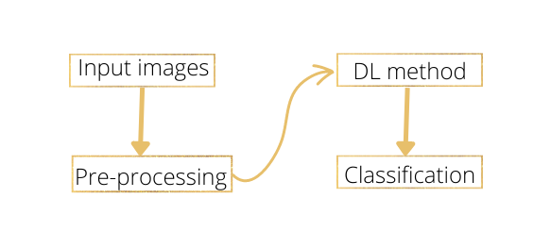
Pre-processing is an important step, while training a deep learning model. The image size can vary with different OEMs and there can be blur and non-useful images. All the images are taken through pre-processing task in which depending on the purpose, some pre-processing methodologies are applied into. The images are then cropped and resized, usually it is 512x512. The said dimension is considered to be the best because it outputs top accuracy, sensitivity, specificity and area under ROC [11]. Grey-scaling of images, if needed are also done with this step. The image ate then analysed, and images without adequate details are removed. If the dataset is unbalanced, it is made balanced by mirroring, and rotating the images. The pre-processed images will be converted into an array. It will be split into train, validation and test, which are 80%, 10% and 10% respectively. and will be taken for the Deep learning method [12].

As stated above, among the pre-trained CNNs, there are four state-of-the art models, which are Xception, InceptionresNet50, ResNet50, and Inception-v3. These models will be trained separately, and will be used for multi-class classification based on the severity of the medical condition. There are mainly three layers associated with a CNN model. It includes convolution layer (CONV), pooling layer, and fully connected layers (FC). The number of layers is not fixed, such that it can be changed based on the users need, and the same goes with the number of filters. There are specific roles attached with the layers of a CNN. Typically, in a CONV layer, different filters try to extract the feature from the input file. The pooling layer helps in reducing the dimension of the features. Usually, average pooling and max pooling are used. The fully connected layer describes the image, while for classification purpose, SoftMax function is used [3].
Vision Transformer (ViT)
The vision transformer is a state-of-the-art deep learning framework. It was used widely in the Natural Language processing tasks. In a ViT, the image inputs are broken into several patches of 16,16. Prior to sending, they are marked with positional markers and are then sent to transformer encoder layers. The benefit of the attention mechanism is that, unlike a CNN, the learnings are not global. It is limited to those areas which need to be learned for the further training.
The architecture of a vision transformer is:
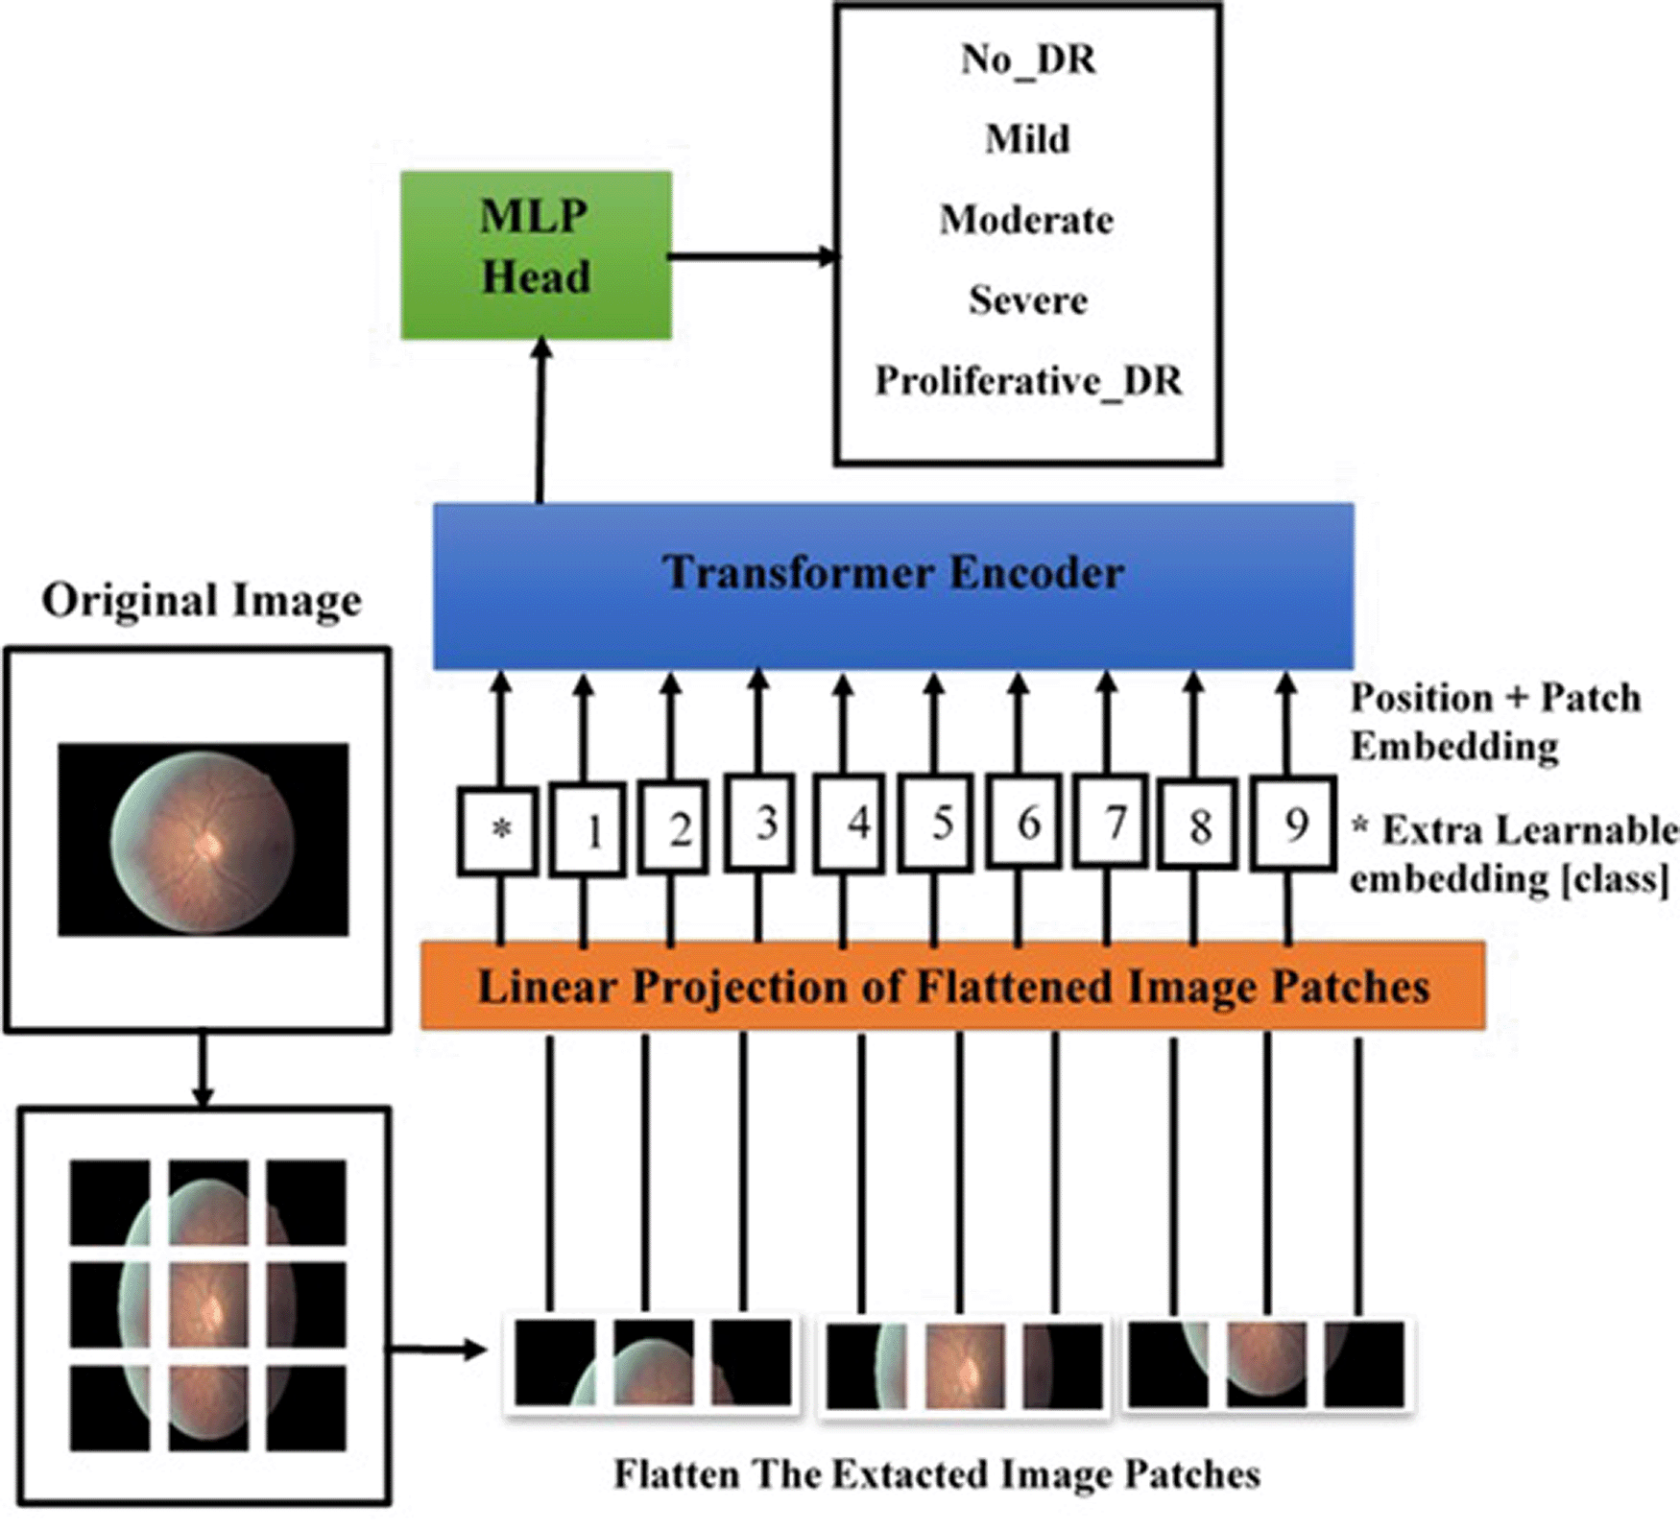
Image credit: [13]

WEB INTERFACE
Deploying a machine learning model in a web interface has many benefits. The main one being it can be utilised by anyone without proper machine learning knowledge. The best example is the recommendation system in Netflix or those prediction websites over the internet, where users benefit from it without knowing about the background working. In case of medical field, when a disease prediction or classification system is deployed over the web, the hospital staff can use it whether it is in the hospital or the field visits. Those portable models can come handy to where there is limited access to medical infrastructure.
The web deployment is mainly done by using Flask framework. The developed Machine Learning model is saved using the pickle library in python. The saved model is then made into an app using the flask. The web app mainly will have three branches, which are:

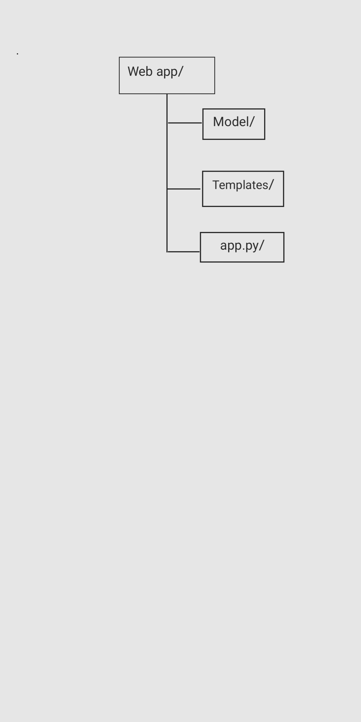
The app.py is the core part, template stores the designed UI while model stores the trained machine learning model. The webpage can be structured using HTML and CSS. It can be deployed over a localhost for the validation and as future work, cloud-based deployment will help in avoiding data loss and faster classifications.

Gantt chart
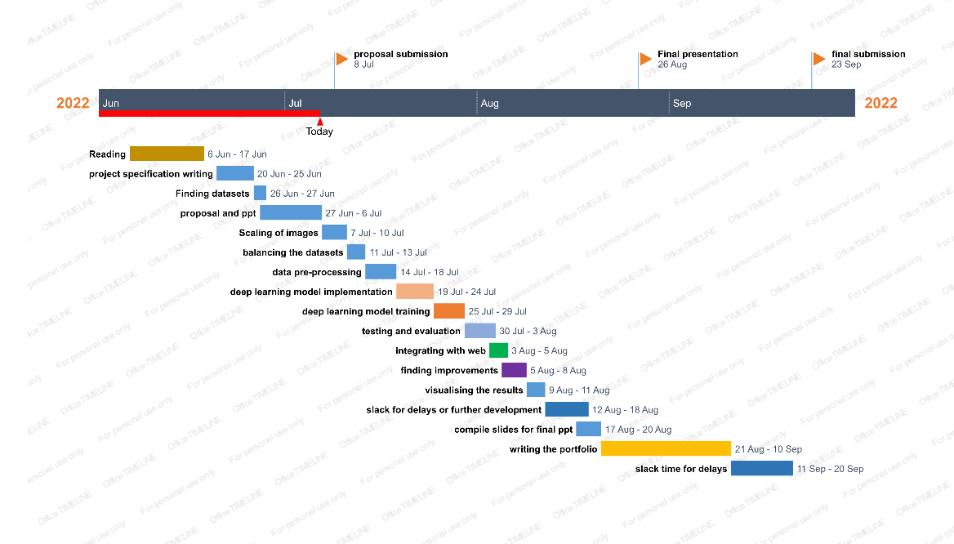
Ethical considerations
Usually medical data deals with a lot of ethical considerations. It is because of the high probability of presence of personal identifiers like name, address, ID etc and the chances of getting one’s health details public. Owing to all these reasons, those data which has these identifiers comes under the GDPR. There should be adequate consent and permissions from the person and institution for the usage of data, and these consents can be reverted at any time. For the good of research, usually the medical records are made public, so that there can be advances in the diagnosis or treatment of a certain condition. For the same, the data will be deidentified, in which there will not be way to link the person.
Resources & Data
For my research, I will be using publicly available datasets only, which are from Kaggle, EyePACS [20], APTOS and Indian Diabetic Retinopathy Image Dataset (IDRID). One among the dataset from EyePACS contains the retinal fundus images from United States. Another dataset is from APTOS, which has the data from India. Apart from the above mentioned, there are many other publicly available datasets. Majority of the datasets are divided into train and test, which can be used for better training and to increase the performance of the model [3]. Usually, for the purpose of retinal imaging, Fundus colour images and Optical Coherence Tomography (OCT) are used. While the OCT images can be either 2 or 3-dimensional, Fundus colour images are 2 dimensional. The examples of retinal images which can be used for the training are:
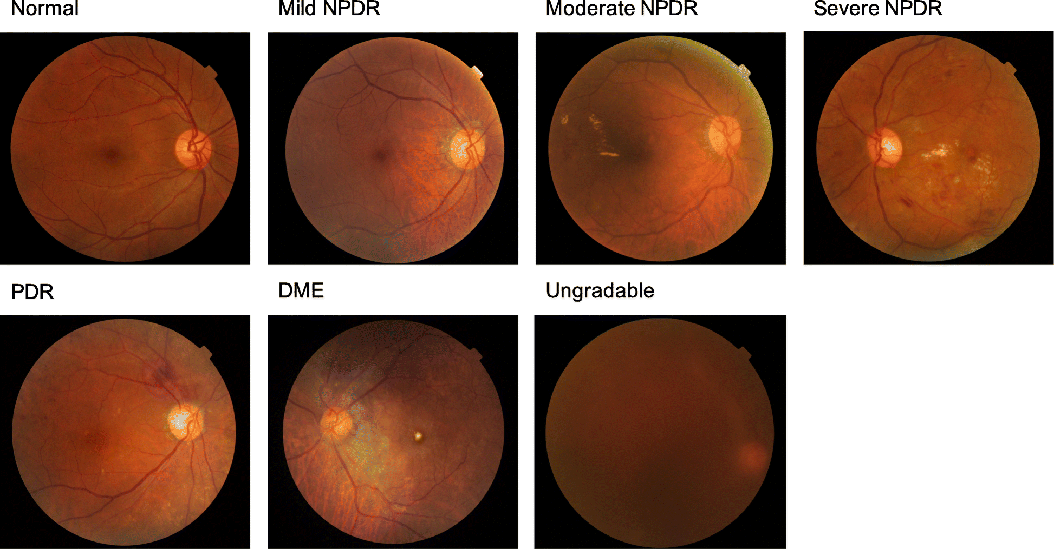
Image credit [15]
The list of available datasets is:
EyePACS dataset from Kaggle: it is a huge dataset, which has high-resolution retina images. It has the images from left and right eye, which are labelled. The images are rated based on the severity from 0 to 4 by a professional [15].
Indian DR Image Dataset: this dataset is relatively small, and it is the only dataset consisting of DR lesions annotated at pixel level [16].
APTOS 2019 Blindness Detection Dataset: Asia Pacific Tele-Ophthalmology Society, with Arvind Hospital in India released this dataset to develop a model which will help the people living in the rural areas where there is limitation for medical access [17].

Testing and Evaluation
The model performance can only be finalised once it is being trained with the available datasets. It is done when the model understands the relationship between the data given in the training data [18]. After the model is being trained, it is tested using the testing dataset for the performance. There are high chances that a model can get errors while training. It badly affects the performance of the model. Understanding how well a trained model works depends on its ability to reduce training errors and the difference between training and testing errors. These bring two key concepts in model training, the underfitting and overfitting. Underfitting happens when the model studies less from the provided training data. A underfitted model will identify lesser details from a training dataset and while testing, it will only classify less details.
Underfitting = High bias + Low Variance
Overfitting on the other hand the model performs well in training dataset, and performs poorly on testing and validation dataset.
Overfitting= Low Bias + High Variance
In order to achieve good results with the model, the overfitting and underfitting needs to be adjusted or there should be a trade-off between bias and variance. Increasing the number of features will help in underfitting, while decreasing will help with overfitting.
Performance Evaluation
The commonly used performance analysis is K-fold evaluation. Here, the datasets are divided into K-sub parts during the training stage. This is achieved by randomly shuffling the dataset and dividing into K subgroups. Then one part is used as a test set and the (K-1) parts are used as training sets. The dataset is trained and tested in this setting, then next part is taken as training and the process is continued [19].
There are a number of ways in which the performance of a model is calculated in machine learning. They include accuracy, specificity, sensitivity, and the ROC curve.
Specificity= TN/(TN+FP)
Sensitivity= TP/(TP+FN)
Accuracy= TN+TP/(TN+TP+FN+FP)
Where,
True positive (TP) are those images with disease, and they are classified as affected. True Negative (TN) is those normal images which as classified as normal. False positive (FP) accounts for the number of normal images, which are classified as disease and False Negative is the number of disease images which are classified as normal [7].
Risks and Contingency Plans

RISKS | LIKELIHOOD | CONSEQUENCES | COUNTER ACTIONS | CONTINGENCY ACTIONS
Moving away from the topic | Low | High | Proper project planning | Proper following of project plan and communication with supervisor
Hardware failure | Low | High | Follow a non-centralised backup measure | Seek guidance from supervisor
Hardware limitations | High | High | Finding alternative compactible methods | Analysing risk prior to the development
Lack of understanding | Low | High | More reading and understanding of concepts | Seek assistance from supervisor, if needed
Bugs in code | Medium | High | Testing the code in fixed intervals | Usage of tech forums to understand more about the bug
Medical condition | High | High | Increased self-care | Following a healthy lifestyle
Not meeting the deadlines | Low | High | Follow the timetables | Keeping enough slack-time to avoid delays

References
[1] nhs.uk. 2022. Diabetic retinopathy. [online] Available at: <https://www.nhs.uk/conditions/diabetic-retinopathy/#:~:text=Diabetic%20retinopathy%20is%20a%20complication,it%20could%20threaten%20your%20sight> [Accessed 6 July 2022].
[2] Nguyen, Q., Muthuraman, R., Singh, L., Sen, G., Tran, A., Nguyen, B. and Chua, M., 2020. Diabetic Retinopathy Detection using Deep Learning. Proceedings of the 4th International Conference on Machine Learning and Soft Computing,.
[3] Alyoubi, W., Shalash, W. and Abulkhair, M., 2020. Diabetic retinopathy detection through deep learning techniques: A review. Informatics in Medicine Unlocked, 20, p.100377.
[4] D. Doshi, A. Shenoy, D. Sidhpura and P. Gharpure, "Diabetic retinopathy detection using deep convolutional neural networks," 2016 International Conference on Computing, Analytics and Security Trends (CAST), 2016, pp. 261-266, doi: 10.1109/CAST.2016.7914977.
[5] Dosovitskiy, Alexey, et al. An Image Is Worth 16x16 Words: Transformers for Image Recognition at Scale. arXiv:2010.11929, arXiv, 3 June 2021. arXiv.org, http://arxiv.org/abs/2010.11929.
[6] Lo, Julian, et al. ‘Federated Learning for Microvasculature Segmentation and Diabetic Retinopathy Classification of OCT Data’. Ophthalmology Science, vol. 1, no. 4, Dec. 2021, p. 100069. ScienceDirect, https://doi.org/10.1016/j.xops.2021.100069.
[7] Hemanth, D. Jude, et al. ‘An Enhanced Diabetic Retinopathy Detection and Classification Approach Using Deep Convolutional Neural Network’. Neural Computing and Applications, vol. 32, no. 3, Feb. 2020, pp. 707–21. Springer Link, https://doi.org/10.1007/s00521-018-03974-0.
[8] Seoud, Lama, et al. ‘Automatic Grading of Diabetic Retinopathy on a Public Database’. Proceedings of the Ophthalmic Medical Image Analysis Second International Workshop, University of Iowa, 2015, pp. 97–104. DOI.org (Crossref), https://doi.org/10.17077/omia.1032.
[9] Acharya, U Rajendra & Lim, Choo & Ng, Eddie & Chee, Caroline & Tamura, Toshiyo. (2009). Computer-based detection of diabetes retinopathy stages using digital fundus images. Proceedings of the Institution of Mechanical Engineers. Part H, Journal of engineering in medicine. 223. 545-53. 10.1243/09544119JEIM486.
[10] Nguyen, Quang H., et al. ‘Diabetic Retinopathy Detection Using Deep Learning’. Proceedings of the 4th International Conference on Machine Learning and Soft Computing, Association for Computing Machinery, 2020, pp. 103–07. ACM Digital Library, https://doi.org/10.1145/3380688.3380709
[11] Reguant, R., Brunak, S. & Saha, S. Understanding inherent image features in CNN-based assessment of diabetic retinopathy. Sci Rep 11, 9704 (2021). https://doi.org/10.1038/s41598-021-89225-0
[12] S. Mishra, S. Hanchate and Z. Saquib, "Diabetic Retinopathy Detection using Deep Learning," 2020 International Conference on Smart Technologies in Computing, Electrical and Electronics (ICSTCEE), 2020, pp. 515-520, doi: 10.1109/ICSTCEE49637.2020.9277506
[13] [ AlDahoul, Nouar, et al. Encoding Retina Image to Words Using Ensemble of Vision Transformers for Diabetic Retinopathy Grading. 10:948, F1000Research, 21 Sept. 2021. f1000research.com, https://f1000research.com/articles/10-948
[14] Lim, Gilbert, et al. ‘Different Fundus Imaging Modalities and Technical Factors in AI Screening for Diabetic Retinopathy: A Review’. Eye and Vision, vol. 7, no. 1, Apr. 2020, p. 21. Springer Link, https://doi.org/10.1186/s40662-020-00182-7
[15] https://www.kaggle.com/competitions/diabetic-retinopathy-detection/data
[16] https://www.kaggle.com/datasets/aaryapatel98/indian-diabetic-retinopathy-image-dataset
[17] https://www.kaggle.com/competitions/aptos2019-blindness-detection/overview
[18] Caballé-Cervigón, Nuria, et al. ‘Machine Learning Applied to Diagnosis of Human Diseases: A Systematic Review’. Applied Sciences, vol. 10, no. 15, Jan. 2020, p. 5135. www.mdpi.com, https://doi.org/10.3390/app10155135
[19] S., Gayathri, et al. ‘A Lightweight CNN for Diabetic Retinopathy Classification from Fundus Images’. Biomedical Signal Processing and Control, vol. 62, Sept. 2020, p. 102115. DOI.org (Crossref), https://doi.org/10.1016/j.bspc.2020.102115.
[20] Cuadros J, Bresnick G. EyePACS: An Adaptable Telemedicine System for Diabetic Retinopathy Screening. Journal of diabetes science and technology (Online). 2009;3(3):509-516
[21] N. S. Kumar and B. Ramaswamy Karthikeyan, "Diabetic Retinopathy Detection using CNN, Transformer and MLP based Architectures," 2021 International Symposium on Intelligent Signal Processing and Communication Systems (ISPACS), 2021, pp. 1-2, doi: 10.1109/ISPACS51563.2021.9651024.

